IDEF3 process flow networks to Arena BE mappings

This document describes the potential content of a BPwin IDEF3 flow network and how this may map to an Arena BE model.

Important points to note:

- Interface will map a single IDEF 3 diagram to a single BE model (hierarchy will not be supported at this time)
- NOT all objects in an IDEF 3 diagram will necessarily map to an Arena BE model
- NOT all objects Arena BE model can be modeled in an IDEF3 model

The concept to drive this is 'what makes best sense' in terms of BOTH tools

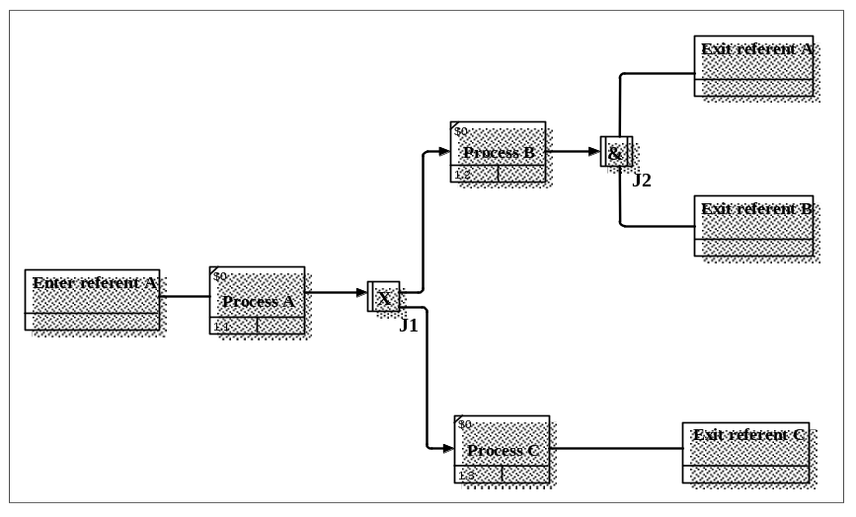

The above diagram shows the basic set of IDEF3 objects that could be exchanged.

The diagram below shows a fan in to a junction. In a real life model a mixture of fan in and fan out situations may well occur. Arena BE has specific objects that handle these situations. See mapping table later in this document.

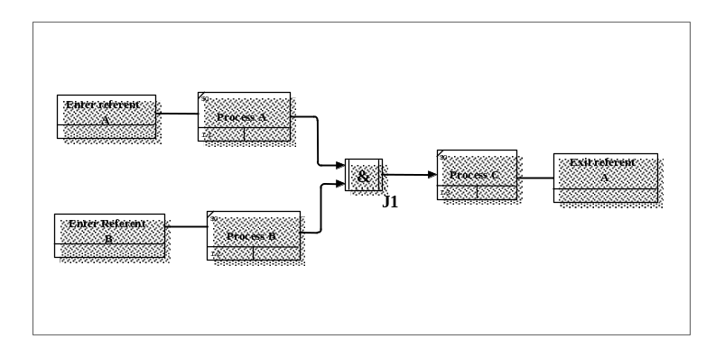

Base mapping table:
BPwin Object | Arena BE Object | Comments
Referent (Link from) | Create Module | * BPwin Link (arrow) style to be modified to allow arrow head to be displayed!
Referent (Link To) | Dispose Module | * BPwin Link (arrow) style to be modified to allow arrow head to be displayed
UOB (IDEF3 activity) | Process Module
Junction (XOR or Sync OR ) | Decide Module | Only allow 2 out going links BUT >2 incoming  More will have to be rejected by the interface.
Junction (& or Async OR) where links (arrows) fan in | Batch Module | * * This could be considered is a "special" activity if desired using UDPs to designate
Junction (& or Async OR) where links (arrows) fan out | Separate Module | Only allow 2 out going links  More will have to be rejected by the interface
Any diagram object dictionary object | Resource Module | The dictionary objects are used only to store resource rows and there is no association between the data and the object on which it is stored.
Arrows (inputs to UOBs representing Process Modules) | Resource or Set repeat group | Data will be associated with the process module into which the arrow sinks. Sets will not be supported for this release.
Not required - see comments | Simulate Module | To be created by the interface
No direct equivalent | Assign Module | Not for this release !  * * This could be considered is a "special" activity if desired using UDPs to designate
No direct equivalent | Record Module | No equivalent possible

The methodology of UDPs attached to the appropriate object (rather like the BP$im interface) will be used to set parameter in the BPwin model before inter change. The next section defines the requirements by object type.

Arena: Create Module/BPwin: Referent (Link From)
Prompt Name | Description | BPwin Meta Property | UDP Name | UDP Datatype |  | UDP Value List
Name | Unique name | Referent Name | N/A | N/A | N/A
Entity type | Name of entity type that will be generated | UDP | Arena_C_EntityType | Text | N/A
Type | Arrival stream type | UDP | Arena_C_ArrivalType | SS Text List | - Constant  - Expression  - Random  - Schedule
Value | Mean of exponent when Random Or Constant | UDP | Arena_C_Value | Real | N/A
Schedule Name | Name of schedule if type schedule | UDP | Arena_C_ScheduleName | Text | N/A
Expression | Distribution or value for time between arrivals | UDP | Arena_C_Expression | Text | N/A
Units | Type of time units | UDP | Arena_C_Units | SS Text List | - days  - hours  - minutes  - seconds
Entities per arrival | # entities entering at a given time | UDP | Arena_C_EntitiesPerArrival | Real | N/A
Max Arrivals | Max # of entries that this module will initiate | UDP | Arena_C_MaxArrivals | Text | N/A
First Creation | Starting time for first arrival | UDP | Arena_C_FirstCreation | Text | N/A

Arena: Process Module/BPwin: UOB (IDEF3 activity)
Prompt Name | Description | BPwin Meta Property |  | UDP Name | UDP Datatype |  | UDP Value List
Name | Unique name | Activity Name | N/A |  | N/A | N/A
Type | Method of Logic | UDP | Arena_P_Type |  | SS Text List | - Standard  - Submodel
Action | Processing type | UDP | Arena_P_Action |  | SS Text List | - Delay  - Delay Release  - Seize Delay  - Seize Delay Release
Priority | Priority value | UDP | Arena_P_Priority |  | Text | N/A
Resources | Repeat group of resources | UDP  V 2.5 | Arena_P_Resources |  | MS Text List | Set by user
Delay Type | Distribution type for delay parms | UDP | Arena_P_DelayType |  | SS Text List | - Constant  - Expression  - Normal  - Triangular  - Uniform
Units | Time units for delay parms | UDP | Arena_P_Units |  | SS Text List | - Days  - hours  - minutes  - seconds
Allocation | How  processing time is allocated | UDP | Arena_P_Allocation |  | SS Text List | - Non-Value Added  - Value Added
Minimum | Minimum value for Uniform or triangular dist | UDP | Arena_P_Minimum |  | Text | N/A
Value | Mean for Normal, Value for Constant, Mode for triangular | UDP | Arena_P_Value |  | Text | N/A
Maximum | Maximum value for Uniform or triangular dist | UDP | Arena_P_Maximum |  | Text | N/A
Std Dev | Std dev for Normal dist | UDP | Arena_P_Std Dev |  | Text | N/A
Expression | Value of expression type | UDP | Arena_P_Expression |  | Text | N/A

Arena: Decide Module/BPwin: Junction (XOR or Sync OR) see conditions in first table
Prompt Name | Description | BPwin Meta Property |  | UDP Name | UDP Datatype |  | UDP Value List
Name | Unique name | Junction Name | N/A |  | N/A | N/A
Type | Type of decision | UDP | Arena_?_Type |  | SS Text List | - By Chance  - By Condition
Percent True | Value % to be checked and sent down the true/false exit points | UDP | Arena_?_PercentTrue |  | Text | N/A
If | Types of conditions available for evaluation | UDP | Arena_?_ConditionType |  | SS Text List | - Attribute  - Entity Type  - Expression  - Variable
VNamed | Name of variable used in conditional statement | UDP | Arena_?_VariableName |  | Text | N/A
ANamed | Name of attribute used in conditional statement | UDP | Arena_?_AttributeName |  | Text | N/A
TypeNamed | Name of Entity Type used in conditional statement | UDP | Arena_?_EntityName |  | Text | N/A
Is | Evaluator | UDP | Arena_?_ConditionEvaluator |  | SS Text List | - <  - <=  - <>  - ==  - >  - >=
Value | Expression used for condition | UDP | Arena_?_ConditionValue |  | Text | N/A

Arena: Dispose Module/BPwin: Referent (Link to)
Prompt Name | Description | BPwin Meta Property |  | UDP Name | UDP Datatype |  | UDP Value List
Name | Unique name | ReferentName | N/A |  | N/A | N/A
Record Entity Statistic | In BE this is a checkbox whether to record or NOT | UDP | Arena_D_RecordEntityStatistic |  | SS Text List | - No  - Yes

Arena: Batch Module/BPwin: Junction (& or Async OR) where links (arrows) fan in
Prompt Name | Description | BPwin Meta Property | UDP Name | UDP Datatype |  | UDP Value List
Name | Unique name | Junction Name | N/A | N/A | N/A
Type | Batch type | UDP | Arena_B_Type | SS Text List | - Permanent  - Temporary
Batch Size | # of entities | UDP | Arena_B_BatchSize | Text | N/A
Rule | How batched | UDP | Arena_B_Rule | SS Text List | - Any Entity  - By Attribute
Attribute Name | Name if Rule set to By attribute | UDP | Arena_B_AttributeName | Text | N/A

Arena: Separate Module/BPwin: Junction (& or Async OR) where links (arrows) fan out See conditions in first table
Prompt Name | Description | BPwin Meta Property | UDP Name | UDP Datatype |  | UDP Value List
Name | Unique name | Junction Name | N/A | N/A | N/A
Type | Separation method type | UDP | Arena_S_Type | SS Text List | - Duplicate Original  - Split Existing Batch
Percent cost to Duplicates | % of entities original cost | UDP | Arena_S_PercentCostToDuplicates | Text | N/A
# of Duplicates | # of outgoing that will leave in addition | UDP | Arena_S_#ofDuplicates | Text | N/A
Allocation Rule | Method of cost and allocation time | UDP | Arena_S_AllocationRule | SS Text List | - Don't Split Costs and Times  - Split All Costs and Times  - Split Only New Costs and Times

Arena: Assign Module/BPwin: UOB (Arena BE object type = Assign) ? Future
Prompt Name | Description | BPwin Meta Property | UDP Name | UDP Datatype |  | UDP Value List
Name | Unique name | Activity Name | N/A | N/A | N/A
Type | Assignment type | UDP | Arena_A_Type | SS Text List | - Attribute  - Entity Picture  - Entity Type  - Other  - Variable
Variable Name | Name if variable | UDP | Arena_A_VariableName | Text | N/A
Attribute Name | Name if Attribute | UDP | Arena_A_AttributeName | Text | N/A
Entity Type Name | Name if Entity Type | UDP | Arena_A_EntityType | Text | N/A
Entity Picture Name | Name if Entity Picture | UDP | Arena_A_EntityPictureName | Text | N/A
Other Name | Name if Other | UDP | Arena_A_OtherName | Text | N/A
New Value | Assignment value if not Entity Type/Picture | UDP | Arena_A_NewValue | Text | N/A

Arena: Resource Module/BPwin: UOB (Arena BE object type = Resource)
Prompt Name | Description | BPwin Meta Property | UDP Name | UDP Datatype |  | UDP Value List
Name | Unique name | UDP | Arena_Res_Name | Text | N/A
Type | Resource type | UDP | Arena_Res_Type | SS Text List | - Fixed Capacity  - Based on Schedule
Capacity | Capacity | UDP | Arena_Res_Capacity | Text | N/A
Schedule Name | Schedule Name | UDP | Arena_Res_ScheduleName | Text | N/A
Busy / Hour | BusyPerHour | UDP | Arena_Res_BusyPerHour | Real | N/A
Idle / Hour | IdlePerHour | UDP | Arena_Res_IdlePerHour | Real | N/A
Per Use | PerUse | UDP | Arena_Res_PerUse | Real | N/A

Arena: Resource Repeat Group/BPwin: Arrow (Arena BE object type = Resource Repeat Group)
Prompt Name | Description | BPwin Meta Property | UDP Name | UDP Datatype |  | UDP Value List
Type | ResourceType | UDP | Arena_ResGroup_Type | SS Text List | - Resource  - Set
Resource Name | ResourceName | UDP | Arena_ResGroup_ResName | Text | N/A
Set Name | SetName | UDP | Arena_ResGroup_SetName | Text | N/A
Quantity | Quantity | UDP | Arena_ResGroup_Quantity | Text | N/A
Selection Rule | SelectionRule | UDP | Arena_ResGroup_SelectionRule | SS Text List | - Cyclical  - Random  - Preferred Order  - Specific Member  - Largest Remaining Capacity  - Smallest Number Busy
Save Attribute | SaveAttribute | UDP | Arena_ResGroup_SaveAttr | Text | N/A
Input Attribute | InputAttribute | UDP | Arena_ResGroup_Input Attr | Text | N/A

